- \Operation\Downstream Machine\Setting
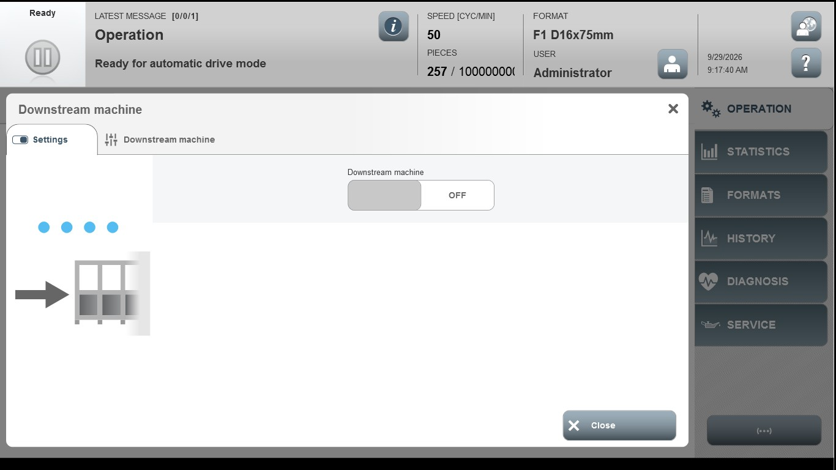
Acceptance criterion | Limits | Pass / Fail: Dev-No. | Date | Initials
Screen matches screenshot | N / A
Response time to downstream machine fault | 0...5000
Operational readiness response time of downstream machine | 0...10000

